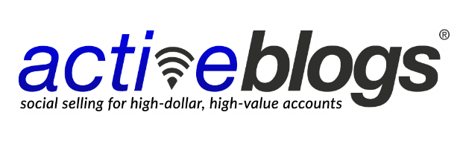
15-Day Challenge

Follow-Up Message Suggestions

When someone replies “No thanks” or some variation thereof:

Sure thing, keep in touch.

When someone shows interest in your service offerings:

Hey [first name], sounds great (acknowledge their response contextually). How does [specific day/time] work to discuss further? Or, feel free to suggest a better time/day and best email, I’ll send you a meeting invite.

To save on back and forth, feel free to use my calendar link here to schedule a time best for you: [scheduling link]. (Link to create a Calendly account: https://calendly.com/)

Chat soon!

[your name]

OR, if you are passing it off to a member of your team:

Thanks for reaching out, I added [team member name], my [team member job title], onto this discussion to follow up and schedule a discussion.

Thanks, and chat soon!

[your name]

When someone says they are not the right person to talk to:

Thanks for letting me know, [first name]. If this sounds useful could you introduce me to the right contact, please?

