15-Day Challenge

The 10-Point Perfect Profile Template

Use this matrix to develop your profile content in real time to the video provided.

☐ 1. Profile URL
Write all your ideas down here and narrow them down to the best options recommended in video.
You can either claim your full name as domain or be more specific to the solutions you provide. For example, www.linkedin.com/in/socialsellingexpert/

☐ 2. Banner Image Recommendations
Find a nice photo that compliments your branding and messaging. Free stock photos can be found here: https://www.pexels.com/. Use a free online image editor like Fotor or Ribbet to crop and add any text or additional images. LinkedIn recommends an image size of 1584 px wide by 396 px tall. You can also utilize online services like Fiverr to commission a LinkedIn banner.
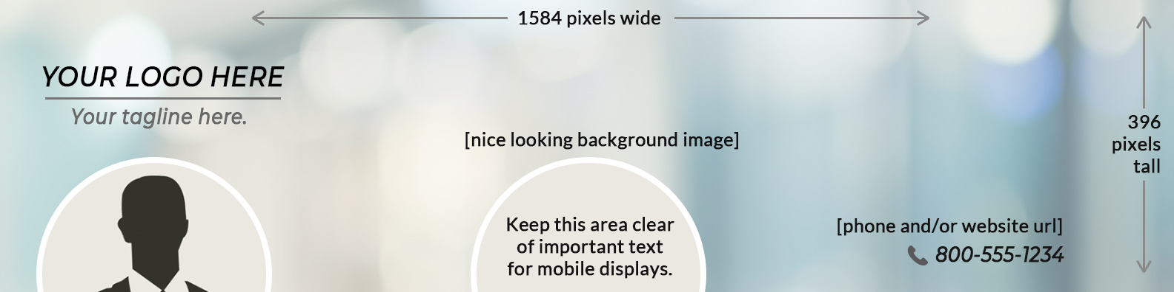

☐ 3. Profile Photo
Wear a nice shirt for a clean headshot.
☐ 4. Name Line
Recommended Name (60 Character Max.) (Recommended — 3 Word Max.)

Example: Connor Dube
☐ 5. Headline
Recommended Headline (120 Character Max, 220 Characters Max uploaded on Mobile app.) First 50 characters should prioritize audience specifics and pain.

This is an opportunity to go slightly more in-depth on your prospects’ pains and how you solve them. This is a great space to use more powerful keywords or questioning that people in your target audience will recognize, relate with, and that will intrigue them to learn more and eventually do business with you.

In this section, we want to touch on the unique end result these prospects will experience.

Consider 5 main points:

- What specific persona/industry/audience are you speaking to?
- What questions would capture your prospects attention and initiate pain? (i.e.,)
- What [XYZ] within their process/business/etc. is broken (i.e.,)
- How will you solve their pain(i.e.,)
- Authority additions

Example: 𝗧𝗲𝗮𝗺’𝘀 𝗦𝗼𝗰𝗶𝗮𝗹 𝗘𝗳𝗳𝗼𝗿𝘁𝘀 𝗙𝗮𝗶𝗹𝗶𝗻𝗴 𝘁𝗼 𝗥𝗲𝗮𝗰𝗵 & 𝗖𝗹𝗼𝘀𝗲 𝗡𝗲𝘄 𝗔𝗰𝗰𝗼𝘂𝗻𝘁𝘀? We Grow Pipelines by 20% & Support B2B Brand Positioning | Event Speaker | Marketing Author | Podcast Host

(write out 4-5 different variations before filling out on your own profile)

- 1
- 2
- 3
- 4
- 5

☐ 6. Contact Info
Everything filled under “See contact info” (right of Headline) when logged into your account and looking at your profile
Profile URL:
Current Website/s:
Phone/Best Contact Number:
Address:
Email:
Twitter:
Additional Links like IM:
Birthday (up to you to share public or private):
☐ 7. Summary Section
↓↓↓ summary draft/copy (2000 character max.) ↓↓↓

Your first sentence should be a call to action. (how to contact you if they are interested)

Then, consider these questions as guidelines for writing:

1. What are the business pain points have you seen/experienced from prospects and clients throughout your time as a [leader] in the industry? (Write1-4 sentences on this.)

2. What are the unique solutions you have discovered are most effective? (Write down as bulleted or short sentences.)

3. Are there scenarios from past experiences that provide a sort of “proof” for the prospect? Or are there further details you can expand on to speak to the prospects’ needs? (2-4 sentences)

4. What is your call to action? (i.e., If you want to see these results/need an industry thought leader as a resource, contact me here) (1 sentence)
☐ 8. Experience
What is most relevant to your current role and past roles that can be of value to your prospects.
☐ 9. Skills and Endorsements
Relevant keywords, highlight top skills you provide for a prospect, organize by most important top to bottom.
☐ 10. Endorsements
Use the ask for recommendations sections to ask for as many requests as possible. Think clients, partners, employers, team members, past clients, vendors.

